**LAB-4**

**Design a VLAN using switch for four departments named CSIT, BCA, MBBS and BIM**

**Aims:**

To understand and creation of VLAN, IP addressing in the VLAN.

**Theory:**

VLAN stands for Virtual LAN. A VLAN is a way of logically separating a group of computers into a separate network. This means they will only communicate with each other and not with any other devices connected to the same physical network. It’s like having a private [wireless network](https://www.extnoc.com/learn/general/wireless-network) at home.

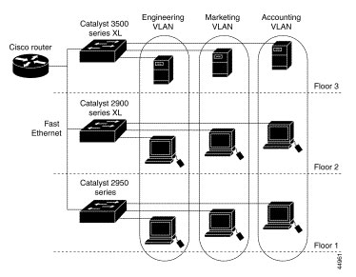

The most common use of [VLANs](https://en.wikipedia.org/wiki/Virtual_LAN) is to separate traffic from different departments or network locations into its subnet, making it easier to manage each group separately. For example, if you run a company where employees are located worldwide, you might want to set up a VLAN for each department so they can communicate without worrying about which country they’re in.

**Advantages of VLAN:**

* It solves a broadcast problem.
* VLAN reduces the size of broadcast domains.
* VLAN allows you to add an additional layer of security.
* It can make device management simple and easier.
* You can make a logical grouping of devices by function rather than location.
* VLAN helps you to geographically structure your network to support the growing companies.
* Higher performance and reduced latency.
* VLANs provide increased performance.
* Users may work on sensitive information that must not be viewed by other users.
* VLAN removes the physical boundary.
* It lets you easily segment your network.
* It helps you to enhance network security.

**Disadvantages of VLAN:**

* A packet can leak from one VLAN to other.
* An injected packet may lead to a cyber-attack.
* Threat in a single system may spread a virus through a whole logical network.

**Application/ Purpose of VLAN**

* VLAN is used when you have 200+ devices on your LAN.
* It is helpful when you have a lot of traffic on a LAN.
* VLAN is ideal when a group of users need more security or being slow down by many broadcasts.
* It is used when users are not on one broadcast domain.
* Make a single switch into multiple switches.

**Procedure:**

Process on setting up a VLAN network in Cisco Packet Tracer.

**Step 1:**Select a central network device and any type of end-devices. I have chosen a switch and 16 PC.

**Step 2:** Create a group of 4pc to set up a VLAN as CSIT, BCA, MBBS, BIT

**Step 3:** Link every device with the switch using copper straight through wire and name the connection.

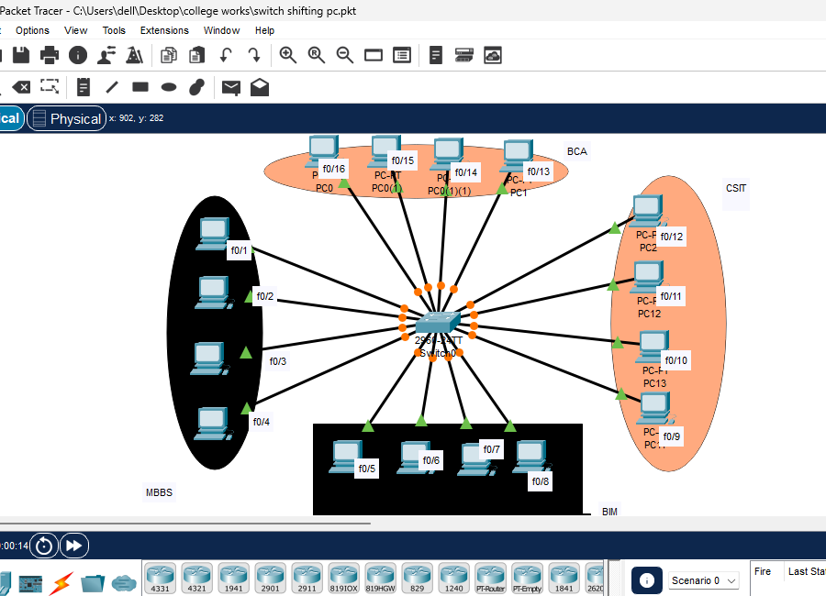

**Step 4:** Provide the IP Address to every device.

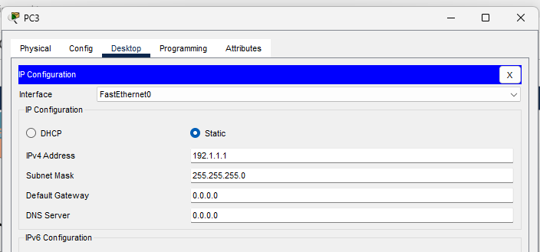

**Step 5:** Open Switch Command Line Interface and type the following commands:

COMMANDS:

* Enable
* Configure terminal

After this command we have to set VLAN ID and name for the VLAN.

The command are:  
 # vlan (id_number)

# name (dept_name)

# exit

Follow this command for every department as follow:

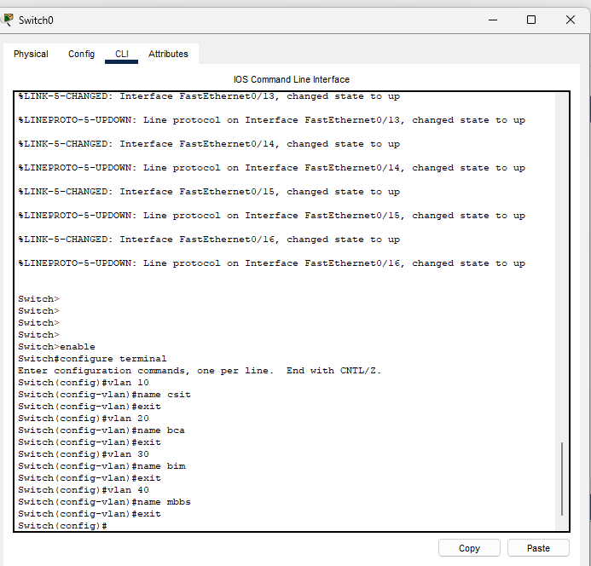

**Step 6:** Configure an interface by using these command:

interface <interface_type> <interface_number>

switchport mode access

switchport access vlan <vlan_id>

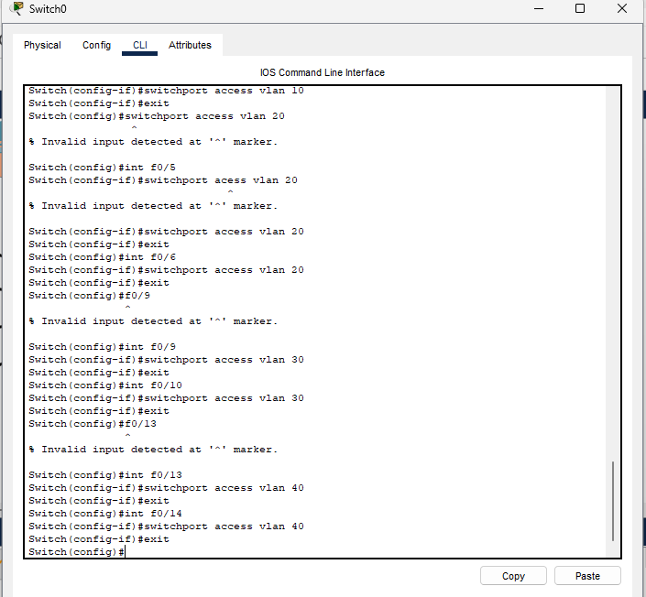

**Step 7:** Check whether the connections are correct. Here I am trying to ping from MBBS department computer (192.1.1.1) to same department and other department computer.

* **Ping to the same department: (successful)**

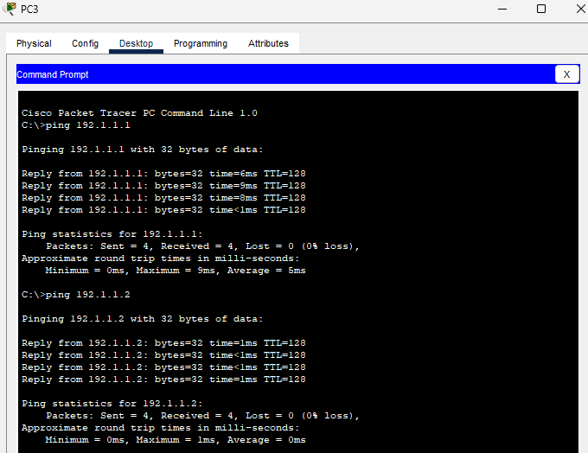

* **Ping to the different department: (Unsuccessful)**

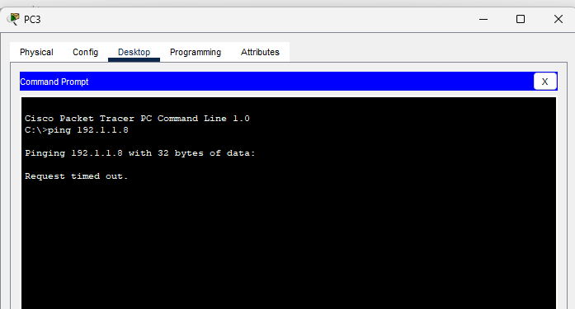

**Conclusion:**

In this lab, we successfully designed a Virtual Local Area Network (VLAN) for four departments named CSIT, BCA, MBBS, and BIM using a Cisco switch in Cisco Packet Tracer. The aim was to understand the creation of VLANs, IP addressing within the VLAN, and the overall process of setting up a segmented network for improved efficiency and security.